Install docker on EC2 and explore the docker commands (docker images, containers, volumes, network)

Creating EC2:

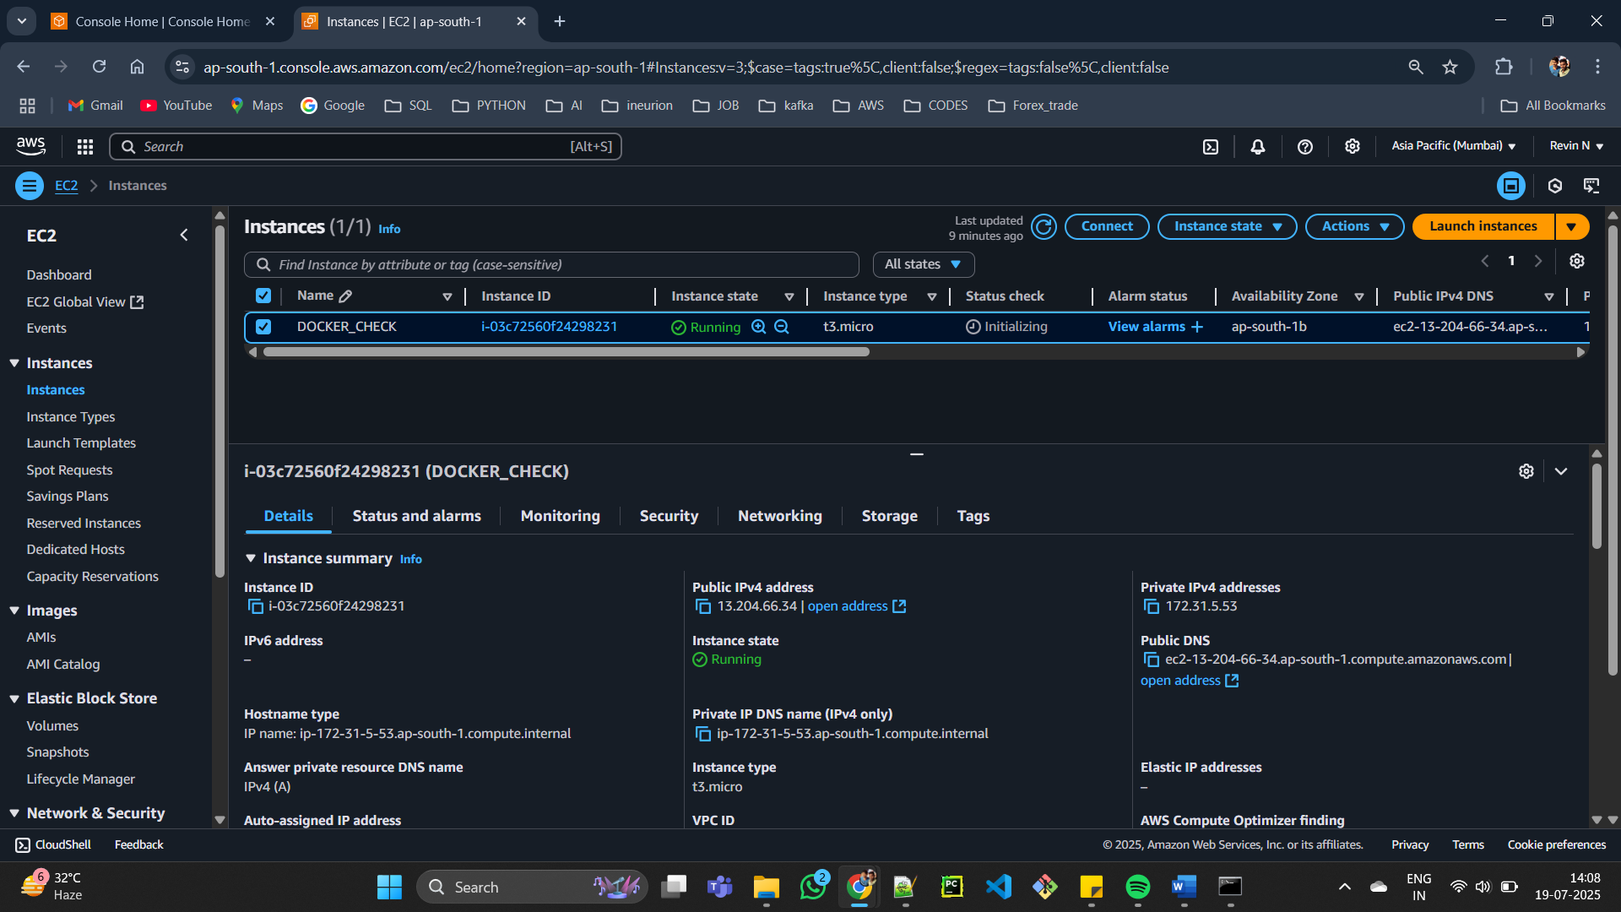

Install docker in UBUNTU:

# Add Dockers official GPG key:

sudo apt-get update

sudo apt-get install ca-certificates curl

sudo install -m 0755 -d /etc/apt/keyrings

sudo curl -fsSL https://download.docker.com/linux/ubuntu/gpg -o /etc/apt/keyrings/docker.asc

sudo chmod a+r /etc/apt/keyrings/docker.asc

# Add the repository to Apt sources:

echo \

"deb [arch=$(dpkg --print-architecture) signed-by=/etc/apt/keyrings/docker.asc] https://download.docker.com/linux/ubuntu \

$(. /etc/os-release && echo "${UBUNTU_CODENAME:-$VERSION_CODENAME}") stable" | \

sudo tee /etc/apt/sources.list.d/docker.list > /dev/null

sudo apt-get update

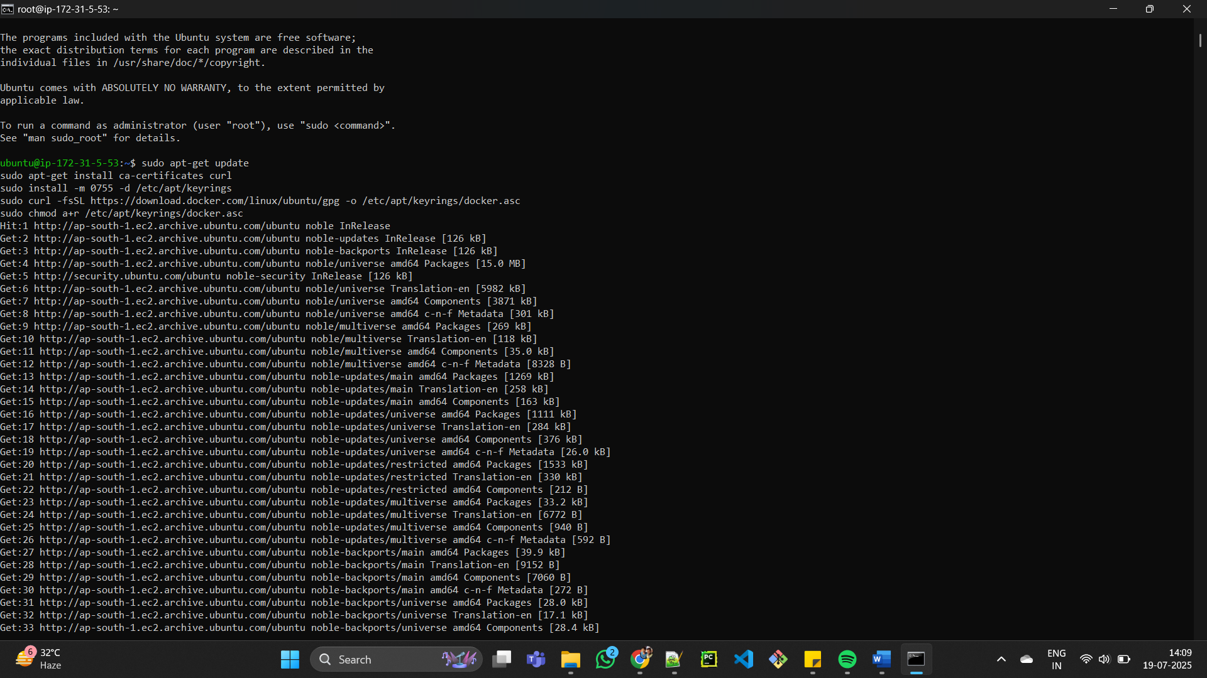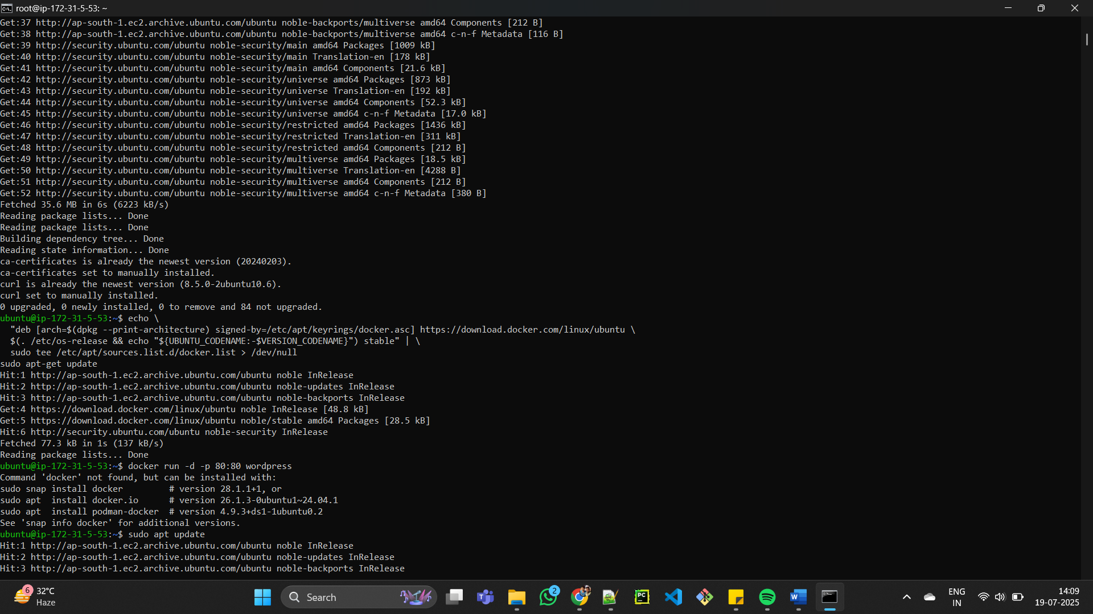

CHECK DOCKER IMG:

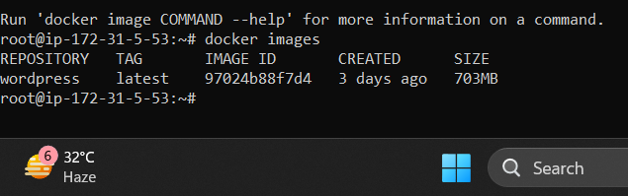

DOCKER CONTAINER:



DOCKER VOLUME:

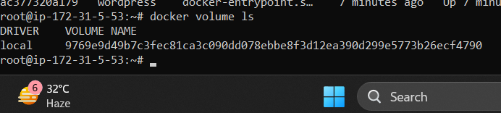

DOCKER NETWORK:

